Active Online Learning for Social media Analysis to Support Crisis Management

In recent years, social media platforms have become vital sources of information during crises and emergencies. They allow for real-time communication and information sharing among a wide range of users. However, the vast amount of data generated during a crisis can be overwhelming. Traditionally, crisis management teams relied on manual methods or simple keyword-based filters to sift through social media data during emergencies. While this approach allowed for some level of information retrieval, it was time-consuming and less efficient in handling the large volume of data generated during a crisis. It also lacked the adaptability and intelligence of machine learning-based systems. During a crisis, timely and accurate information is paramount for effective response and management. Active online learning, a subset of machine learning, offers a potential solution by dynamically selecting and labelling the most informative data points for analysis. The use of social media (SM) in crisis management gained prominence in the early 21st century, with platforms like Twitter and Facebook becoming crucial channels for information dissemination during emergencies. Therefore, the proposed system employs active online learning which addresses the needs by automating the process of selecting and analyzing the most relevant and informative data points, enabling more efficient crisis response. The problem of active online learning for social media analysis in crisis management involves developing a system that can autonomously select and label the most informative posts or messages related to a crisis. The goal is to filter out noise and focus on the data that is most likely to provide critical insights for crisis response and management. By leveraging machine learning algorithms, this approach can dynamically select and label data points that are most likely to provide valuable insights for crisis response. This enables crisis management teams to focus their attention on the most relevant information, improving the speed and effectiveness of their response efforts.

CHAPTER 1
INTRODUCTION
1.1 Overview
The primary task of crisis management is to identify specific actions that need to be carried out before (prevention, preparedness), during (response), and after (recovery and mitigation) a crisis occurred [28]. In order to execute these tasks efficiently, it is helpful to use data from various sources including the public as witnesses of emergency events. Such data would enable emergency operations centers to act and organize the rescue and response. In recent years, a number of research studies [49] have investigated the use of social media as a source of information for efficient crisis management. A selection of such studies, among others, encompasses Norway Attacks [47], Minneapolis Bridge Collapse [35], California Wildfire [64], Colorado Floods [18], and Australia Bushfires [23], [22]. The extensive use of SM by people forces (re)thinking the public engagement in crisis management regarding the new available technologies and resulting opportunities [13].
A previous work on SM in emergency response focused on offline and online clustering of SM messages. The offline clustering approach [50] was applied to identify sub-events (specific hotspots) from SM data of a crisis for an after-the-fact analysis. Online clustering [48] was used to identify sub-events that evolve over time in a dynamic way. In particular, online feature selection mechanisms were devised as well, so that SM data streams can be accommodated continuously and incrementally. It is interesting to note that people from emergency departments (e.g., police forces) already use SM to gather, monitor, and to disseminate information to inform the public [21].
Hence, we propose a learning algorithm, AOMPC, that relies on active learning to accommodate the user’s feedback upon querying the item being processed. Since AOMPC is a classifier, the query is related to labelling that item. The primary goal in using user-generated contents of SM is to discriminate valuable information from irrelevant one. We propose classification as the discrimination method. The classifier plays the role of a filtering machinery. With the help of the user, it recognizes the important SM items (e.g., tweets), that are related to the event of interest. The selected items are used as cues to identify sub-events. Note that an event is the crisis as such, while sub-events are the topics commonly discussed (i.e., hotspots like flooding, collapsing of bridges, etc. in a specific area of a city) during a crisis. These sub-events can be identified by aggregating the messages posted on SM networks describing the same specific topic [48], [51].
1.2 Objective
We propose a Learning Vector Quantization (LVQ)- like approach based on multiple prototype classification. The classifier operates online to deal with the evolving stream of data. The algorithm, named active online multiple prototype classifier (AOMPC), uses unlabelled and labeled data which are tagged through active learning. Data items which fall into ambiguous regions are selected for labelling by the user. The number of queries is controlled by a budget. The requested items help to direct the AOMPC classifier to a better discriminatory capability. While AOMPC can be applied to any streaming data, here we consider in particular SM data.

CHAPTER 2
LITERATURE SURVEY

The problem addressed in this paper is related to several topics: multiple prototype and Learning Vector Quantization (LVQ) classification, online learning for classification, active learning with budget planning, and social media analysis (i.e., natural language processing). A short overview of these topics is presented in the following.
2.1 Multiple Prototype Classification and LVQ Classification
A prototype-based classification approach operates on data items mapped to a vector representation (e.g., vector space model for text data). Data points are classified via prototypes considering similarity measures. Prototypes are adapted based on items related/similar to them. A Rocchio classifier [37] is an example of a single prototype-based classifier. It distinguishes between two classes, e.g., “relevant” and “irrelevant”. In real world-scenarios, due to the nature of the data, it is often not possible to describe the data with a single prototype-based classifier. Multiple prototype classifiers (i.e., several prototypes) are needed.
Self-organizing maps (SOM) introduced by Kohonen [32] are an unsupervised version of prototype-based classification, also known as LVQ. In this case, prototypes are initialized (e.g., randomized) and adapted. SOM was also used for SM analysis in the context of crisis management to identify important hotspots [50]. LVQ has been applied to several areas, e.g., robotics, pattern recognition, image processing, text classification etc. [20], [32], [62]. LVQ - in the context of similarity representation, rather than vector-based representation - is analyzed by Hammer et al. [25].
Mokbel et al. [40] describe an approach to learn metrics for different LVQ classification tasks. They suggest a metric adaptation strategy to automatically adapt metric parameters. Bezdek et al. [6] review several offline multiple prototype classifiers, e.g., LVQ, fuzzy LVQ, and the deterministic Dog-Rabbit (DR) model. The latter limits the movement of prototypes and is similar to our approach. However, in contrast to our approach, DR uses offline adaptation of the learning rate. The time-based learning rate of our algorithm considers concept drift (i.e., changes of the incoming data) directly during the update of the prototypes.
In contrast to the previous approaches, Bouchachia [8] proposes an incremental supervised LVQ-like competitive algorithm that operates online. It consists of two stages. In the first stage (learning stage), the notions of winner reinforcement and rival repulsion are applied to update the weights of the prototypes. In the second stage (control stage), two mechanisms, staleness and dispersion are used to get rid of dead and redundant prototypes. A summary of different prototype-based learning approaches can be found in Biehl et al. [7]. In this study, we deal with online real-time classification, and we propose a multi-prototype quantization algorithm, where the winning prototype is adapted based on the input. In particular, the algorithm relies on online learning and active learning.
2.2 Online Learning and Active Learning (with Budget Planning)
Online learning receives data items in a continuous sequence and processes them once to classify them accordingly [66]. Bouchachia and Vanaret [10], [11] use Growing Gaussian Mixture Models for online classification. Compared to the algorithm proposed in this work, there is a difference in adapting the learning rate and representing the prototypes. Reuter et al. [54] use multiple prototypes representing an event. New incoming items are assigned to the most similar events (by using an offline-trained SVM) or otherwise new events are created. Another important topic in streaming analysis is active learning to improve results of classification with an amount of labeled data actively asked by the system [57].
Ienco et al. [29] use a pre-clustering step to identify relevant items to be labeled by the user. In Smailovic et al. [59] active learning is used to ´ improve the sentiment analysis of incoming tweets as an indicator for stock movements. Hao et al. [27] design two active learning algorithms (Active Exponentially Weighted Average Forecaster and Active Greedy Forecaster) which includes feedback of experts for labeling. The approach considers confidence of labels from the classifier compared to a set of experts. Hao et al. [26] also introduce online active learning considering second order information, e.g., based on covariance matrix. Ma et al. [36] combine decision trees with active learning. This approach improves the learning step for decision trees. Bouguelia et al. [12] use instance weighting for active online learning. They consider the weight that must be changed to cause the classifier changing its prediction. If only a small change in weight changes the original classification, then the classifier is highest uncertain about the item. Mohamad et al. [39] introduce an active learning algorithm for data streams with concept evolution. In addition, they suggest a bi-criteria active learning algorithm by including both label uncertainty and density of the underlying distribution [38].
Monzafari et al. [41] study different batch-based active learning approaches and define two uncertainty strategies to query labels from crowdsourcing platforms. In addition, the authors also define a budget or goal constraint to limit labeling. Zliobait ˇ e et al. [65] ˙ use active learning combined with streaming data. They suggest several processing mechanisms to identify uncertainty regions especially for handling data drifts. It is also important to minimize the number of queries, asking an expert for labels. Zliobait ˇ e et al. [65] ˙ include a moving average over the incoming items and the amount of already labeled items to estimate the budget. We adopted this mechanism together with the uncertainty strategies. Based on categorization of active learning approaches by Settles et al. [57], our implementation is classified as a stream-based selective sampling approach, considering different strategies to request instances for labeling. In addition, we use an online feature selection approach described later.
2.3 Social Media Analysis for Crisis Management
Recent research studies SM from several technical perspectives. Due to space limitations, we describe existing SM analysis frameworks mostly in the context of crisis management, although there are several frameworks in other contexts, e.g., Twitterbeat [58] and HarVis [2]. Backfried et al. [3] describe an analysis approach based on visual analytics for combining information from different sources with a specific focus on multilingual issues. Vieweg and Hodges [30], [63] describe the Artificial Intelligence for Disaster Response (AIDR) platform, where persons annotate incoming tweets (similar to Amazon Mechanical Turk). The tweets are then used to train classifiers to identify more relevant tweets. AIDR allows to classify incoming tweets based on different information categories, e.g., damage report, casualties, advises, etc.
Chen et al. [15] analyse tweets related to Flu to identify topics for predicting the Flu-peak. Neppalli et al. [42] perform sentiment analysis based on social media related to Hurricane Sandy. The work shows that sentiment of users is related to the distance of the Hurricane to the users. Twitcident described by Abel et al. [1] is a framework to search and filter Twitter messages through specific profiles (e.g., keywords). Terpstra et al. [61] show the usage of Twitcident in crisis management. Tweak-the-Tweet introduced by Starbird et al. [60] defines a grammar which can be easily integrated in tweets and therefore automatically parsed. Also, TEDAS described by Li et al. [34] is a system to detect high-level events (e.g., all car accidents in a certain time period) using spatial and temporal information. Yin et al. [68], [67] design a situational awareness platform for SM. Tweets are analyzed based on bursty keywords to identify emergent incidents.
Ragini et al. [52] combine several techniques to identify people in danger. They examined rule-based classification and several machine learning approaches, like SVM, for hybrid classification. Additional information on social media analysis in different crises can be found in Reuter and Kaufhold [53]. Due to the importance of SM, it is our aim to support emergency management when using the content of SM platforms. Currently, there are systems with crowd-sourcing platform characteristics, but no procedure (like active learning) is available to directly involve emergency management personnel in filtering relevant information.

CHAPTER 3
EXISTING SYSTEM
The traditional system heavily relies on manual efforts for data collection, preprocessing, analysis, and decision-making, which can be labour-intensive, time-consuming, and potentially less accurate compared to automated systems powered by machine learning and natural language processing techniques. In addition, they suffer from inefficiency, lack of scalability, limited coverage, subjectivity, delayed insights, incapability to handle multimodal data, absence of predictive analytics, and potential security and privacy challenges. Embracing modern data analytics techniques, machine learning algorithms, natural language processing, and real-time processing capabilities can overcome these limitations, enabling organizations to make data-driven decisions swiftly and effectively during crisis situations.
Limitations
1. Manual Analysis: Traditional systems often rely on manual analysis of social media data during crises. Analysts manually sift through vast amounts of textual information, making it time-consuming and prone to human error. Manual methods are inefficient for processing large datasets, especially in real-time scenarios where timely responses are crucial.
2. Lack of Scalability: Conventional approaches lack scalability. As the volume of social media data increases exponentially during crises, traditional systems struggle to handle the data influx effectively. Scaling up manual efforts to match the growing data volume becomes impractical and financially burdensome.
3. Limited Coverage: Manual analysis has limited coverage and might miss crucial data points. Analysts might not be able to process every tweet or post, leading to incomplete insights. This limitation hampers the system's ability to provide a comprehensive understanding of the crisis landscape.
4. Subjectivity and Bias: Human analysts are subjective, and their interpretations can be influenced by biases. This subjectivity might affect the accuracy and reliability of the analysis. Additionally, cultural and language biases can impact the interpretation of social media content, leading to skewed results.
5. Lack of Real-time Insights: Traditional systems often suffer from a lack of real-time data processing capabilities. Delayed analysis means that decision-makers receive insights after a considerable lag, hindering the ability to respond promptly to unfolding events.
6. Inability to Handle Multimodal Data: With the rise of multimedia content on social media platforms (images, videos, audio), traditional systems, primarily designed for textual data, struggle to analyze and extract meaningful insights from multimodal content. Failure to incorporate these diverse data types results in incomplete analysis.
7. Absence of Predictive Analytics: Traditional systems focus on historical data analysis and lack predictive analytics capabilities. Predicting future events or trends, which is vital for proactive crisis management, is beyond the scope of conventional methods.
8. Security and Privacy Concerns: Traditional systems might not adequately address security and privacy concerns associated with social media data. Ensuring the privacy of individuals while collecting and analyzing data is essential, and traditional approaches may lack robust mechanisms for safeguarding sensitive information.

CHAPTER 4
PROPOSED SYSTEM
4.1 Project Overview
4.1.1 Objective
The project aims to analyze social media data to unveil patterns and trends, enabling timely decision-making during crisis situations. It focuses on predicting the location of tweets based on their content.
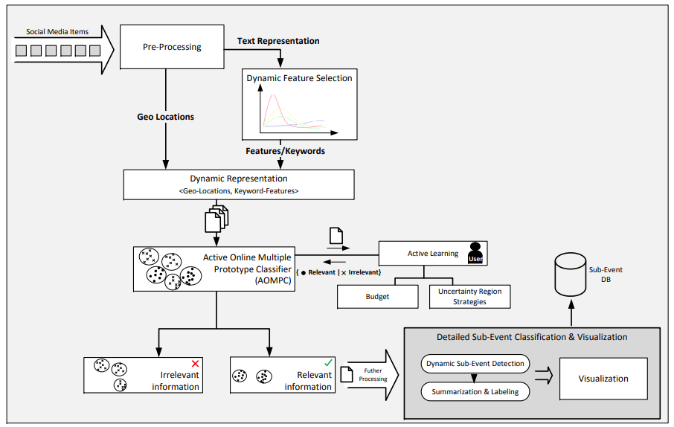
Figure 4.1: Proposed system architecture.
4.1.2 Key Components
1. Graphical User Interface (GUI):
- The project provides a user-friendly interface using Tkinter, a Python library for creating GUI applications.
- Users can upload a dataset containing social media posts and their corresponding locations through the GUI.
2. Data Preprocessing:
- The uploaded dataset is preprocessed to clean the text data. The cleanText and cleanPost functions are used for this purpose.
- Text cleaning involves tasks such as removing punctuation, special characters, digits, and stopwords. It also includes lemmatization and stemming to reduce words to their base or root form.
3. Feature Extraction:
- The preprocessed text data is converted into numerical features using TF-IDF (Term Frequency-Inverse Document Frequency) vectorization.
- TF-IDF is a numerical statistic used to reflect the importance of a word in a document relative to a collection of documents.
4. Machine Learning Model (Naive Bayes):
- The project employs the Naive Bayes algorithm for text classification.
- The Multinomial Naive Bayes classifier is trained on the preprocessed and vectorized data.
- Performance metrics such as accuracy, precision, recall, and F1-score are calculated to evaluate the model's effectiveness.
5. Prediction:
- Users can input a tweet through the GUI, and the trained Naive Bayes model predicts its location.
- The input tweet undergoes the same preprocessing steps as the training data before being fed into the model for prediction.
6. Visualization: The project includes a visualization component that displays the confusion matrix using seaborn and matplotlib. The confusion matrix provides insights into the model's performance by showing the true positive, true negative, false positive, and false negative predictions.
7. Persistence and Optimization:
- The trained Naive Bayes model and the TF-IDF vectorizer are persisted using pickle, allowing the application to reuse the trained model without retraining every time the program runs.
- The project optimizes the training process by saving intermediate results (X and Y arrays) to avoid redundant preprocessing steps.
4.1.3 Usage Flow
- Upload Dataset: Users upload a CSV file containing social media posts and their associated locations.
- Data Preprocessing: The uploaded data is cleaned and preprocessed to remove noise and irrelevant information.
- Feature Extraction: The preprocessed text data is converted into numerical features using TF-IDF vectorization.
- Model Training: The Naive Bayes classifier is trained on the preprocessed data.
- Prediction: Users input a tweet, and the trained model predicts its location based on the learned patterns from the training data.
- Result Visualization: The confusion matrix and various performance metrics are displayed, providing insights into the model's accuracy and reliability.

CHAPTER 5
UML DIAGRAMS
UML stands for Unified Modeling Language. UML is a standardized general-purpose modeling language in the field of object-oriented software engineering. The standard is managed, and was created by, the Object Management Group. The goal is for UML to become a common language for creating models of object-oriented computer software. In its current form UML is comprised of two major components: a Meta-model and a notation. In the future, some form of method or process may also be added to; or associated with, UML.
The Unified Modeling Language Is a standard language for specifying, Visualization, Constructing and documenting the artifacts of software system, as well as for business modeling and other non-software systems. The UML represents a collection of best engineering practices that have proven successful in the modeling of large and complex systems. The UML is a very important part of developing objects-oriented software and the software development process. The UML uses mostly graphical notations to express the design of software projects.
GOALS: The Primary goals in the design of the UML are as follows:
- Provide users a ready-to-use, expressive visual modeling Language so that they can develop and exchange meaningful models.
- Provide extendibility and specialization mechanisms to extend the core concepts.
- Be independent of particular programming languages and development process.
- Provide a formal basis for understanding the modeling language.
- Encourage the growth of OO tools market.
- Support higher level development concepts such as collaborations, frameworks, patterns and components.
- Integrate best practices.
Class Diagram
The class diagram is used to refine the use case diagram and define a detailed design of the system. The class diagram classifies the actors defined in the use case diagram into a set of interrelated classes. The relationship or association between the classes can be either an “is-a” or “has-a” relationship. Each class in the class diagram may be capable of providing certain functionalities. These functionalities provided by the class are termed “methods” of the class. Apart from this, each class may have certain “attributes” that uniquely identify the class.
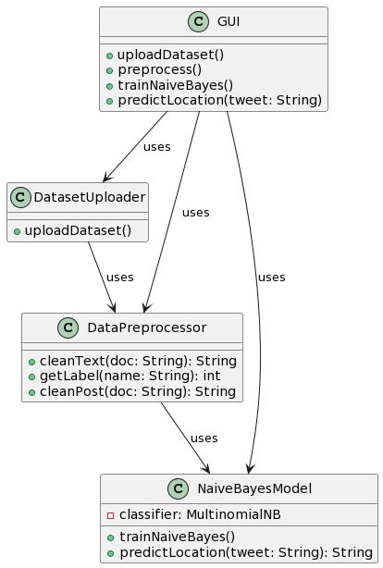

Data flow diagram
A Data Flow Diagram (DFD) is a visual representation of the flow of data within a system or process. It is a structured technique that focuses on how data moves through different processes and data stores within an organization or a system. DFDs are commonly used in system analysis and design to understand, document, and communicate data flow and processing.
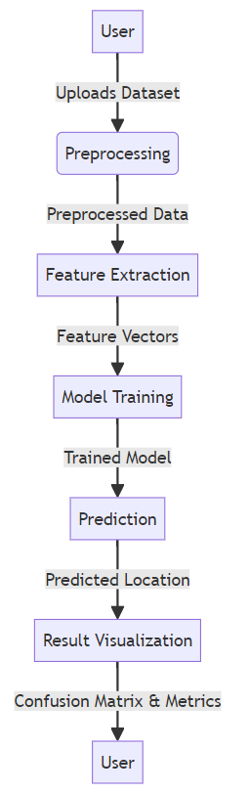

Sequence Diagram
A sequence diagram in Unified Modeling Language (UML) is a kind of interaction diagram that shows how processes operate with one another and in what order. It is a construct of a Message Sequence Chart. A sequence diagram shows, as parallel vertical lines (“lifelines”), different processes or objects that live simultaneously, and as horizontal arrows, the messages exchanged between them, in the order in which they occur. This allows the specification of simple runtime scenarios in a graphical manner.
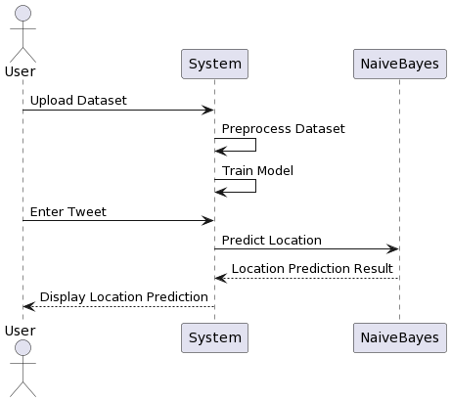

Use case diagram
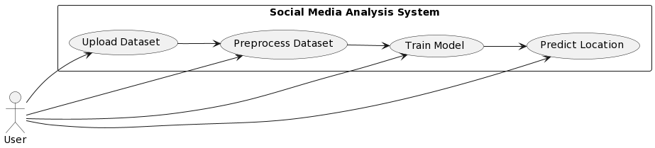

Activity diagram
Activity diagram is another important diagram in UML to describe the dynamic aspects of the system.
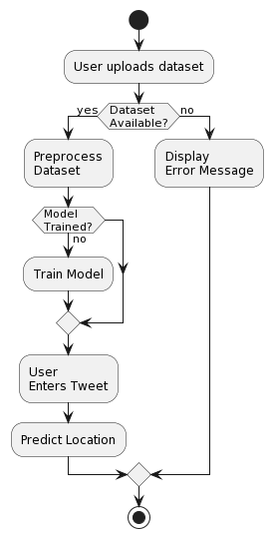

CHAPTER 6
SOFTWARE ENVIRONMENT
What is Python?
Below are some facts about Python.
- Python is currently the most widely used multi-purpose, high-level programming language.
- Python allows programming in Object-Oriented and Procedural paradigms. Python programs generally are smaller than other programming languages like Java.
- Programmers have to type relatively less and indentation requirement of the language, makes them readable all the time.
- Python language is being used by almost all tech-giant companies like – Google, Amazon, Facebook, Instagram, Dropbox, Uber… etc.
The biggest strength of Python is huge collection of standard library which can be used for the following –
- Machine Learning
- GUI Applications (like Kivy, Tkinter, PyQt etc. )
- Web frameworks like Django (used by YouTube, Instagram, Dropbox)
- Image processing (like Opencv, Pillow)
- Web scraping (like Scrapy, BeautifulSoup, Selenium)
- Test frameworks
- Multimedia
Advantages of Python
Let’s see how Python dominates over other languages.
- Extensive Libraries
Python downloads with an extensive library and it contain code for various purposes like regular expressions, documentation-generation, unit-testing, web browsers, threading, databases, CGI, email, image manipulation, and more. So, we don’t have to write the complete code for that manually.
2. Extensible
As we have seen earlier, Python can be extended to other languages. You can write some of your code in languages like C++ or C. This comes in handy, especially in projects.
3. Embeddable
Complimentary to extensibility, Python is embeddable as well. You can put your Python code in your source code of a different language, like C++. This lets us add scripting capabilities to our code in the other language.
4. Improved Productivity
The language’s simplicity and extensive libraries render programmers more productive than languages like Java and C++ do. Also, the fact that you need to write less and get more things done.
5. IOT Opportunities
Since Python forms the basis of new platforms like Raspberry Pi, it finds the future bright for the Internet Of Things. This is a way to connect the language with the real world.
6. Simple and Easy
When working with Java, you may have to create a class to print ‘Hello World’. But in Python, just a print statement will do. It is also quite easy to learn, understand, and code. This is why when people pick up Python, they have a hard time adjusting to other more verbose languages like Java.
7. Readable
Because it is not such a verbose language, reading Python is much like reading English. This is the reason why it is so easy to learn, understand, and code. It also does not need curly braces to define blocks, and indentation is mandatory. This further aids the readability of the code.
8. Object-Oriented
This language supports both the procedural and object-oriented programming paradigms. While functions help us with code reusability, classes and objects let us model the real world. A class allows the encapsulation of data and functions into one.

9. Free and Open-Source
Like we said earlier, Python is freely available. But not only can you download Python for free, but you can also download its source code, make changes to it, and even distribute it. It downloads with an extensive collection of libraries to help you with your tasks.
10. Portable
When you code your project in a language like C++, you may need to make some changes to it if you want to run it on another platform. But it isn’t the same with Python. Here, you need to code only once, and you can run it anywhere. This is called Write Once Run Anywhere (WORA). However, you need to be careful enough not to include any system-dependent features.
- Interpreted
Lastly, we will say that it is an interpreted language. Since statements are executed one by one, debugging is easier than in compiled languages.
Any doubts till now in the advantages of Python? Mention in the comment section.
Advantages of Python Over Other Languages
- Less Coding
Almost all of the tasks done in Python requires less coding when the same task is done in other languages. Python also has an awesome standard library support, so you don’t have to search for any third-party libraries to get your job done. This is the reason that many people suggest learning Python to beginners.
2. Affordable
Python is free therefore individuals, small companies or big organizations can leverage the free available resources to build applications. Python is popular and widely used so it gives you better community support.
The 2019 Github annual survey showed us that Python has overtaken Java in the most popular programming language category.

3. Python is for Everyone
Python code can run on any machine whether it is Linux, Mac or Windows. Programmers need to learn different languages for different jobs but with Python, you can professionally build web apps, perform data analysis and machine learning, automate things, do web scraping and also build games and powerful visualizations. It is an all-rounder programming language.
Disadvantages of Python
So far, we’ve seen why Python is a great choice for your project. But if you choose it, you should be aware of its consequences as well. Let’s now see the downsides of choosing Python over another language.
- Speed Limitations
We have seen that Python code is executed line by line. But since Python is interpreted, it often results in slow execution. This, however, isn’t a problem unless speed is a focal point for the project. In other words, unless high speed is a requirement, the benefits offered by Python are enough to distract us from its speed limitations.
2. Weak in Mobile Computing and Browsers
While it serves as an excellent server-side language, Python is much rarely seen on the client-side. Besides that, it is rarely ever used to implement smartphone-based applications. One such application is called Carbonnelle.
The reason it is not so famous despite the existence of Brython is that it isn’t that secure.
3. Design Restrictions
As you know, Python is dynamically typed. This means that you don’t need to declare the type of variable while writing the code. It uses duck-typing. But wait, what’s that? Well, it just means that if it looks like a duck, it must be a duck. While this is easy on the programmers during coding, it can raise run-time errors.
4. Underdeveloped Database Access Layers
Compared to more widely used technologies like JDBC (Java DataBase Connectivity) and ODBC (Open DataBase Connectivity), Python’s database access layers are a bit underdeveloped. Consequently, it is less often applied in huge enterprises.
5. Simple
No, we’re not kidding. Python’s simplicity can indeed be a problem. Take my example. I don’t do Java, I’m more of a Python person. To me, its syntax is so simple that the verbosity of Java code seems unnecessary.
This was all about the Advantages and Disadvantages of Python Programming Language.
Modules Used in Project
NumPy
NumPy is a general-purpose array-processing package. It provides a high-performance multidimensional array object, and tools for working with these arrays.
It is the fundamental package for scientific computing with Python. It contains various features including these important ones:
- A powerful N-dimensional array object
- Sophisticated (broadcasting) functions
- Tools for integrating C/C++ and Fortran code
- Useful linear algebra, Fourier transform, and random number capabilities
Besides its obvious scientific uses, NumPy can also be used as an efficient multi-dimensional container of generic data. Arbitrary datatypes can be defined using NumPy which allows NumPy to seamlessly and speedily integrate with a wide variety of databases.
Pandas
Pandas is an open-source Python Library providing high-performance data manipulation and analysis tool using its powerful data structures. Python was majorly used for data munging and preparation. It had very little contribution towards data analysis. Pandas solved this problem. Using Pandas, we can accomplish five typical steps in the processing and analysis of data, regardless of the origin of data load, prepare, manipulate, model, and analyze. Python with Pandas is used in a wide range of fields including academic and commercial domains including finance, economics, Statistics, analytics, etc.
Matplotlib
Matplotlib is a Python 2D plotting library which produces publication quality figures in a variety of hardcopy formats and interactive environments across platforms. Matplotlib can be used in Python scripts, the Python and Ipython shells, the Jupyter Notebook, web application servers, and four graphical user interface toolkits. Matplotlib tries to make easy things easy and hard things possible. You can generate plots, histograms, power spectra, bar charts, error charts, scatter plots, etc., with just a few lines of code. For examples, see the sample plots and thumbnail gallery.
For simple plotting the pyplot module provides a MATLAB-like interface, particularly when combined with Ipython. For the power user, you have full control of line styles, font properties, axes properties, etc, via an object oriented interface or via a set of functions familiar to MATLAB users.
Scikit – learn
Scikit-learn provides a range of supervised and unsupervised learning algorithms via a consistent interface in Python. It is licensed under a permissive simplified BSD license and is distributed under many Linux distributions, encouraging academic and commercial use. Python
Install Python Step-by-Step in Windows and Mac
Python a versatile programming language doesn’t come pre-installed on your computer devices. Python was first released in the year 1991 and until today it is a very popular high-level programming language. Its style philosophy emphasizes code readability with its notable use of great whitespace.
The object-oriented approach and language construct provided by Python enables programmers to write both clear and logical code for projects. This software does not come pre-packaged with Windows.
How to Install Python on Windows and Mac
There have been several updates in the Python version over the years. The question is how to install Python? It might be confusing for the beginner who is willing to start learning Python but this tutorial will solve your query. The latest or the newest version of Python is version 3.7.4 or in other words, it is Python 3.
Note: The python version 3.7.4 cannot be used on Windows XP or earlier devices.
Before you start with the installation process of Python. First, you need to know about your System Requirements. Based on your system type i.e. operating system and based processor, you must download the python version. My system type is a Windows 64-bit operating system. So the steps below are to install python version 3.7.4 on Windows 7 device or to install Python 3. Download the Python Cheatsheet here.The steps on how to install Python on Windows 10, 8 and 7 are divided into 4 parts to help understand better.
Download the Correct version into the system
Step 1: Go to the official site to download and install python using Google Chrome or any other web browser. OR Click on the following link: https://www.python.org
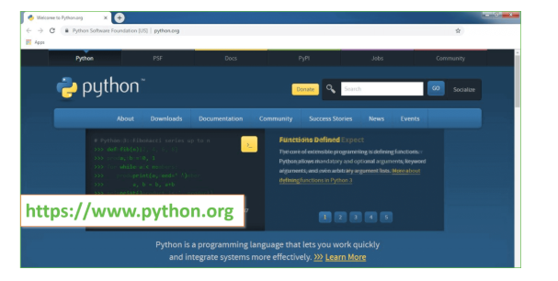
Now, check for the latest and the correct version for your operating system.
Step 2: Click on the Download Tab.
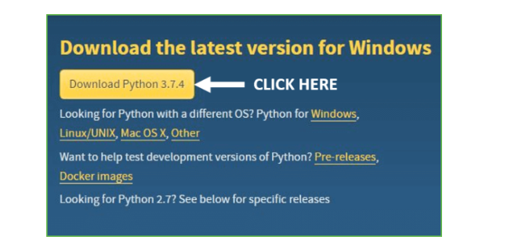
Step 3: You can either select the Download Python for windows 3.7.4 button in Yellow Color or you can scroll further down and click on download with respective to their version. Here, we are downloading the most recent python version for windows 3.7.4
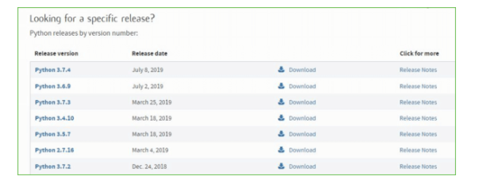
Step 4: Scroll down the page until you find the Files option.
Step 5: Here you see a different version of python along with the operating system.
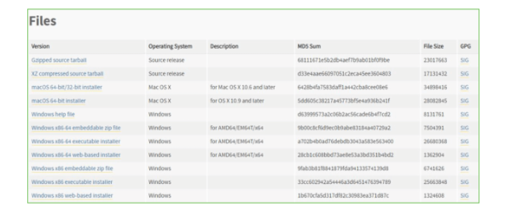
- To download Windows 32-bit python, you can select any one from the three options: Windows x86 embeddable zip file, Windows x86 executable installer or Windows x86 web-based installer.
- To download Windows 64-bit python, you can select any one from the three options: Windows x86-64 embeddable zip file, Windows x86-64 executable installer or Windows x86-64 web-based installer.
Here we will install Windows x86-64 web-based installer. Here your first part regarding which version of python is to be downloaded is completed. Now we move ahead with the second part in installing python i.e. Installation
Note: To know the changes or updates that are made in the version you can click on the Release Note Option.
Installation of Python
Step 1: Go to Download and Open the downloaded python version to carry out the installation process.
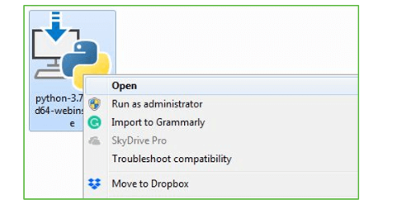
Step 2: Before you click on Install Now, Make sure to put a tick on Add Python 3.7 to PATH.
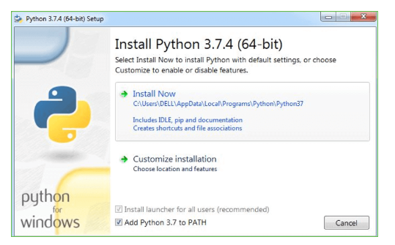
Step 3: Click on Install NOW After the installation is successful. Click on Close.
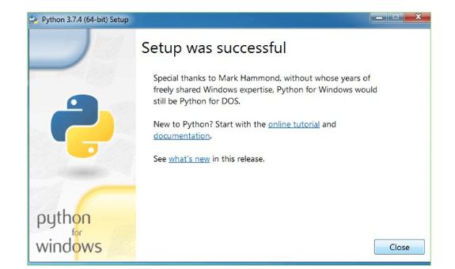
With these above three steps on python installation, you have successfully and correctly installed Python. Now is the time to verify the installation.
Note: The installation process might take a couple of minutes.
Verify the Python Installation
Step 1: Click on Start
Step 2: In the Windows Run Command, type “cmd”.
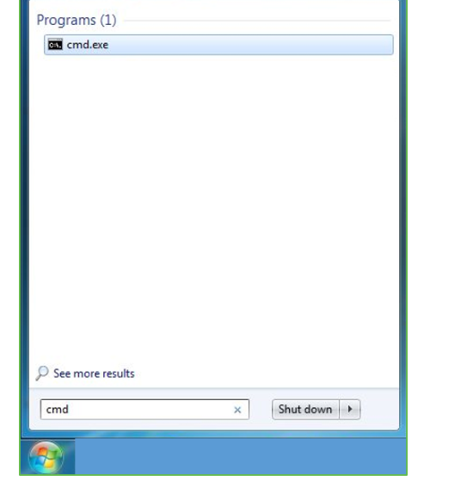
Step 3: Open the Command prompt option.
Step 4: Let us test whether the python is correctly installed. Type python –V and press Enter.
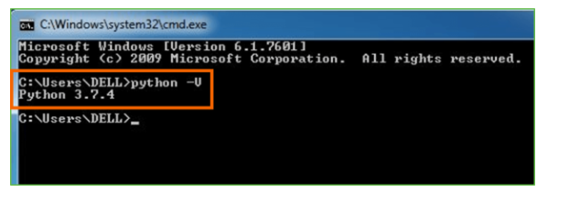

Step 5: You will get the answer as 3.7.4
Note: If you have any of the earlier versions of Python already installed. You must first uninstall the earlier version and then install the new one.
Check how the Python IDLE works
Step 1: Click on Start
Step 2: In the Windows Run command, type “python idle”.
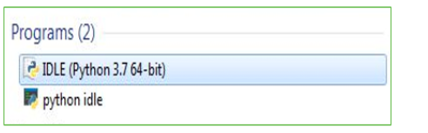
Step 3: Click on IDLE (Python 3.7 64-bit) and launch the program
Step 4: To go ahead with working in IDLE you must first save the file. Click on File > Click on Save
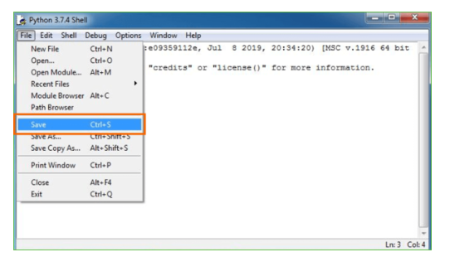
Step 5: Name the file and save as type should be Python files. Click on SAVE. Here I have named the files as Hey World.
Step 6: Now for e.g. enter print (“Hey World”) and Press Enter.
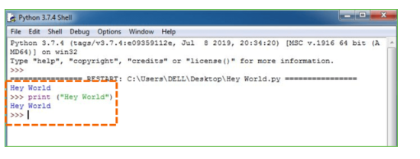
You will see that the command given is launched. With this, we end our tutorial on how to install Python. You have learned how to download python for windows into your respective operating system.
Note: Unlike Java, Python does not need semicolons at the end of the statements otherwise it won’t work.

CHAPTER 7
SYSTEM REQUIREMENTS
Software Requirements
The functional requirements or the overall description documents include the product perspective and features, operating system and operating environment, graphics requirements, design constraints and user documentation.
The appropriation of requirements and implementation constraints gives the general overview of the project in regard to what the areas of strength and deficit are and how to tackle them.
- Python IDLE 3.7 version (or)
- Anaconda 3.7 (or)
- Jupiter (or)
- Google colab

Hardware Requirements
Minimum hardware requirements are very dependent on the particular software being developed by a given Enthought Python / Canopy / VS Code user. Applications that need to store large arrays/objects in memory will require more RAM, whereas applications that need to perform numerous calculations or tasks more quickly will require a faster processor.
- Operating system : Windows, Linux
- Processor : minimum intel i3
- Ram : minimum 4 GB
- Hard disk : minimum 250GB

CHAPTER 8
FUNCTIONAL REQUIREMENTS

Output Design
Outputs from computer systems are required primarily to communicate the results of processing to users. They are also used to provides a permanent copy of the results for later consultation. The various types of outputs in general are:
- External Outputs, whose destination is outside the organization
- Internal Outputs whose destination is within organization and they are the
- User’s main interface with the computer.
- Operational outputs whose use is purely within the computer department.
- Interface outputs, which involve the user in communicating directly.
Output Definition
The outputs should be defined in terms of the following points:
- Type of the output
- Content of the output
- Format of the output
- Location of the output
- Frequency of the output
- Volume of the output
- Sequence of the output
It is not always desirable to print or display data as it is held on a computer. It should be decided as which form of the output is the most suitable.
Input Design
Input design is a part of overall system design. The main objective during the input design is as given below:
- To produce a cost-effective method of input.
- To achieve the highest possible level of accuracy.
- To ensure that the input is acceptable and understood by the user.
Input Stages
The main input stages can be listed as below:
- Data recording
- Data transcription
- Data conversion
- Data verification
- Data control
- Data transmission
- Data validation
- Data correction
Input Types
It is necessary to determine the various types of inputs. Inputs can be categorized as follows:
- External inputs, which are prime inputs for the system.
- Internal inputs, which are user communications with the system.
- Operational, which are computer department’s communications to the system?
- Interactive, which are inputs entered during a dialogue.
Input Media
At this stage choice has to be made about the input media. To conclude about the input media consideration has to be given to;
- Type of input
- Flexibility of format
- Speed
- Accuracy
- Verification methods
- Rejection rates
- Ease of correction
- Storage and handling requirements
- Security
- Easy to use
- Portability
Keeping in view the above description of the input types and input media, it can be said that most of the inputs are of the form of internal and interactive. As
Input data is to be the directly keyed in by the user, the keyboard can be considered to be the most suitable input device.
Error Avoidance
At this stage care is to be taken to ensure that input data remains accurate form the stage at which it is recorded up to the stage in which the data is accepted by the system. This can be achieved only by means of careful control each time the data is handled.
Error Detection
Even though every effort is make to avoid the occurrence of errors, still a small proportion of errors is always likely to occur, these types of errors can be discovered by using validations to check the input data.
Data Validation
Procedures are designed to detect errors in data at a lower level of detail. Data validations have been included in the system in almost every area where there is a possibility for the user to commit errors. The system will not accept invalid data. Whenever an invalid data is keyed in, the system immediately prompts the user and the user has to again key in the data and the system will accept the data only if the data is correct. Validations have been included where necessary.
The system is designed to be a user friendly one. In other words the system has been designed to communicate effectively with the user. The system has been designed with popup menus.
User Interface Design
It is essential to consult the system users and discuss their needs while designing the user interface:
User Interface Systems Can Be Broadly Clasified As:
- User initiated interface the user is in charge, controlling the progress of the user/computer dialogue. In the computer-initiated interface, the computer selects the next stage in the interaction.
- Computer initiated interfaces
In the computer-initiated interfaces the computer guides the progress of the user/computer dialogue. Information is displayed and the user response of the computer takes action or displays further information.
User Initiated Interfaces
User initiated interfaces fall into two approximate classes:
- Command driven interfaces: In this type of interface the user inputs commands or queries which are interpreted by the computer.
- Forms oriented interface: The user calls up an image of the form to his/her screen and fills in the form. The forms-oriented interface is chosen because it is the best choice.
Computer-Initiated Interfaces
The following computer – initiated interfaces were used:
- The menu system for the user is presented with a list of alternatives and the user chooses one; of alternatives.
- Questions – answer type dialog system where the computer asks question and takes action based on the basis of the users reply.
Right from the start the system is going to be menu driven, the opening menu displays the available options. Choosing one option gives another popup menu with more options. In this way every option leads the users to data entry form where the user can key in the data.
Error Message Design
The design of error messages is an important part of the user interface design. As user is bound to commit some errors or other while designing a system the system should be designed to be helpful by providing the user with information regarding the error he/she has committed.
This application must be able to produce output at different modules for different inputs.
Performance Requirements
Performance is measured in terms of the output provided by the application. Requirement specification plays an important part in the analysis of a system. Only when the requirement specifications are properly given, it is possible to design a system, which will fit into required environment. It rests largely in the part of the users of the existing system to give the requirement specifications because they are the people who finally use the system. This is because the requirements have to be known during the initial stages so that the system can be designed according to those requirements. It is very difficult to change the system once it has been designed and on the other hand designing a system, which does not cater to the requirements of the user, is of no use.
The requirement specification for any system can be broadly stated as given below:
- The system should be able to interface with the existing system
- The system should be accurate
- The system should be better than the existing system
- The existing system is completely dependent on the user to perform all the duties.

CHAPTER 9
CONCLUSIONS

In conclusion, the Social Media Crisis Analytics project offers a robust solution for understanding patterns and trends within social media data, enabling timely decision-making during crises. By harnessing the power of natural language processing and machine learning techniques, the project successfully preprocesses and analyzes social media posts. The preprocessing step ensures that the textual data is cleaned, transformed, and optimized for analysis. Through TF-IDF vectorization, the project effectively converts the textual content into numerical features, facilitating the training of a Naive Bayes classifier.
The trained model exhibits strong predictive capabilities, accurately determining the geographical location of tweets based on their content. Utilizing metrics such as accuracy, precision, recall, and F1-score, the model's performance is evaluated, providing valuable insights into its effectiveness. Additionally, the project visualizes results through a confusion matrix, enhancing the interpretability of the model's predictions.
This project not only showcases the potential of natural language processing and machine learning in social media analytics but also highlights the importance of data-driven decision-making during crisis situations. The developed graphical user interface enhances user accessibility, allowing stakeholders to effortlessly upload datasets, process data, train the model, and obtain real-time predictions. Overall, the project's success lies in its ability to empower users with actionable insights derived from social media data, enabling informed and proactive responses during critical events.
Future scope
The project's future scope includes expanding the model's capabilities to handle multilingual and multimedia content, enabling analysis of diverse social media data. Integration with real-time data sources and advanced sentiment analysis techniques could enhance the system's responsiveness and accuracy. Implementing deep learning architectures like recurrent neural networks (RNNs) or transformer models could capture complex contextual relationships in text, further improving location prediction accuracy. Moreover, incorporating geospatial visualization tools and interactive dashboards would enhance the project's usability, aiding decision-makers in understanding crisis patterns intuitively. Continuous updates and retraining the model with evolving social media trends ensure the system remains effective in capturing emerging crisis-related insights, making it a valuable tool for proactive crisis management in the future.

REFERENCES
[1] F. Abel, C. Hauff, G.-J. Houben, R. Stronkman, and K. Tao, “Semantics + Filtering + Search = Twitcident. Exploring Information in Social Web Streams,” in Proc. of the 23rd ACM Conf. on Hypertext and Social Media. ACM, 2012, pp. 285–294.
[2] U. Ahmad, A. Zahid, M. Shoaib, and A. AlAmri, “Harvis: An integrated social media content analysis framework for youtube platform,” Information Systems, vol. 69, pp. 25 – 39, 2017.
[3] G. Backfried, J. Gollner, G. Qirchmayr, K. Rainer, G. Kienast, G. Thallinger, C. Schmidt, and A. Peer, “Integration of Media Sources for Situation Analysis in the Different Phases of Disaster Management: The QuOIMA Project,” in Eur. Intel. and Security Informatics Conf., Aug 2013, pp. 143–146.
[4] BBC News Europe. (2012, Aug.) England Riots: Maps and Timeline. [Online]. Available: http://www.bbc.co.uk/news/ uk-14436499
[5] H. Becker, M. Naaman, and L. Gravano, “Learning Similarity Metrics for Event Identification in Social Media,” in Proc. of the Third ACM Int’l Conf. on Web Search and Data Mining, ser. WSDM ’10. NY, USA: ACM, 2010, pp. 291–300. [6] J. Bezdek, T. Reichherzer, G. Lim, and Y. Attikiouzel, “MultiplePrototype Classifier Design,” IEEE Trans. on Systems, Man, and Cybernetics, Part C: Applications and Reviews, vol. 28, no. 1, pp. 67– 79, Feb 1998.
[7] M. Biehl, B. Hammer, and T. Villmann, “Prototype-based Models in Machine Learning,” Wiley Interdisciplinary Reviews: Cognitive Science, vol. 7, no. 2, pp. 92–111, 2016.
[8] A. Bouchachia, “Learning with Incrementality,” in Proc. of the Int’l Conf. on Neural Information Processing, 2006, pp. 137–146.
[9] ——, “Incremental Learning with Multi-Level Adaptation,” Neurocomputing, vol. 74, no. 11, pp. 1785–1799, 2011.
[10] A. Bouchachia and C. Vanaret, “Incremental Learning Based on Growing Gaussian Mixture Models,” in 10th Int’l Conf. on Machine Learning and Applications and Workshops (ICMLA), vol. 2, Dec 2011, pp. 47–52.
[11] ——, “GT2FC: An Online Growing Interval Type-2 Self-Learning Fuzzy Classifier,” IEEE Transactions on Fuzzy Systems, vol. 22, no. 4, pp. 999–1018, 2014.
[12] M.-R. Bouguelia, Y. Bela¨ıd, and A. Bela¨ıd, “An Adaptive Streaming Active Learning Strategy based on Instance Weighting,” Pattern Recognition Letters, vol. 70, pp. 38 – 44, 2016.
[13] M. Buscher and M. Liegl, “Connected Communities in Crises,” ¨ in Social Media Analysis for Crisis Management, H. Hellwagner, D. Pohl, and R. Kaiser, Eds. IEEE Computer Society Special Technical Community on Social Networking E-Letter, March 2014, vol. 2, no. 1.
[14] G. Cavallanti, N. Cesa-Bianchi, and C. Gentile, “Tracking the best Hyperplane with a simple Budget Perceptron,” Machine Learning, vol. 69, no. 2-3, pp. 143–167, 2007.
[15] L. Chen, K. S. M. Tozammel Hossain, P. Butler, N. Ramakrishnan, and B. A. Prakash, “Syndromic Surveillance of Flu on Twitter Using Weakly Supervised Temporal Topic Models,” Data Mining and Knowledge Discovery, vol. 0, no. 3, pp. 681–710, May 2016.
[16] T. M. Cover and J. A. Thomas, “Entropy, Relative Entropy and Mutual Information,” in Elements of Information Theory. New Jersey: A John Wiley & Sons, 2006.
[17] K. Crammer, O. Dekel, J. Keshet, S. Shalev-Shwartz, and Y. Singer, “Online Passive-Aggressive Algorithms,” J. Mach. Learn. Res., vol. 7, pp. 551–585, Dec. 2006.
[18] S. Dashti, L. Palen, M. P. Heris, K. M. Anderson, S. Anderson, and S. Anderson, “Supporting Disaster Reconnaissance with Social Media Data: A Design-Oriented Case Study of the 2013 Colorado Floods,” in Proc. of the 11th Int’l Conference on Information Systems for Crisis Response and Management, University Park, Pennsylvania, USA, 2014.
[19] O. Dekel, S. Shalev-Shwartz, and Y. Singer, “The Forgetron: A Kernel-Based Perceptron on a Fixed Budget,” in NIPS. MIT Press, 2005, pp. 259–266.
[20] A. Denecke, H. Wersing, J. Steil, and E. Korner, “Online figure- ¨ ground segmentation with adaptive metrics in generalized LVQ,” Neurocomputing, vol. 72, no. 7-9, pp. 1470 – 1482, 2009.
[21] S. Denef, P. S. Bayerl, and N. Kaptein, “Social Media and the Police - Tweeting Practices of British Police Forces during the August 2011 Riots,” in Proc. of the SIGCHI Conf. on Human Factors in Computing Systems (CHI), Paris, France, May 2013.
[22] N. Dufty, “Using Social Media to build Community Disaster Resilience,” The Australian Journal of Emergency Management, vol. 27, no. 1, pp. 40–45, 2012.
[23] M. Freeman and A. Freeman, “Bonding over Bushfires: Social Networks in Action,” in IEEE International Symposium on Technology and Society (ISTAS), June 2010, pp. 419–426.
[24] J. a. Gama, I. Zliobait ˇ e, A. Bifet, M. Pechenizkiy, and A. Bou- ˙ chachia, “A Survey on Concept Drift Adaptation,” ACM Comput. Surv., vol. 46, no. 4, pp. 44:1–44:37, 2014.
[25] B. Hammer, D. Hofmann, F.-M. Schleif, and X. Zhu, “Learning Vector Quantization for (dis-)similarities,” Neurocomputing, vol. 131, pp. 43 – 51, 2014.
[26] S. Hao, J. Lu, P. Zhao, C. Zhang, S. C. H. Hoi, and C. Miao, “Second-Order Online Active Learning and Its Applications,” IEEE Transactions on Knowledge and Data Engineering, vol. 30, no. 7, pp. 1338–1351, July 2018.
[27] S. Hao, P. Hu, P. Zhao, S. C. H. Hoi, and C. Miao, “Online Active Learning with Expert Advice,” ACM Trans. Knowl. Discov. Data, vol. 12, no. 5, pp. 58:1–58:22, 2018.
[28] S. R. Hiltz, B. van de Walle, and M. Turoff, “The Domain of Emergency Management Information,” in Information Systems for Emergency Management. Armonk, New York: B. van de Walle, M. Truoff and S. R. Hiltz, 2010, vol. 16, pp. 3–19.
[29] D. Ienco, A. Bifet, I. Zliobait ˇ e, and B. Pfahringer, “Clustering ˙ Based Active Learning for Evolving Data Streams,” in Discovery Science, ser. Lecture Notes in Computer Science, J. Furnkranz, ¨ E. Hullermeier, and T. Higuchi, Eds. Springer Berlin Heidelberg, ¨ 2013, vol. 8140, pp. 79–93.
[30] M. Imran, C. Castillo, J. Lucas, P. Meier, and S. Vieweg, “AIDR: Artificial Intelligence for Disaster Response,” in Proc. of the Companion Publication of the 23rd Int’l Conf. on World Wide Web, ser. WWW Companion ’14, April 2014, pp. 159–162.
[31] Y. Ishikawa, Y. Chen, and H. Kitagawa, “An On-Line Document Clustering Method Based on Forgetting Factors,” in Research and Advanced Technology for Digital Libraries, ser. Lecture Notes in Computer Science, P. Constantopoulos and I. T. Solvberg, Eds. Springer, 2001, vol. 2163, pp. 325–339.
[32] T. Kohonen, “The Self-Organizing Map,” Proc. of the IEEE, vol. 78, no. 9, pp. 1464 –1480, Sep 1990. [33] V. I. Levenshtein, “Binary Codes Capable of Correcting Deletions, Insertions and Reversals,” in Soviet physics doklady, vol. 10, 1966, p. 707.
[34] R. Li, K. H. Lei, R. Khadiwala, and K.-C. Chang, “TEDAS: A Twitter-based Event Detection and Analysis System,” in IEEE 28th Int’l Conf. on Data Engineering (ICDE), 2012, pp. 1273–1276.
[35] S. Liu, L. Palen, J. Sutton, A. Hughes, and S. Vieweg, “In Search of the Bigger Picture: The Emergent Role of On-Line Photo-Sharing in Times of Disaster,” in Proc. of the 5th Int’l ISCRAM Conf., 2008.
[36] L. Ma, S. Destercke, and Y. Wang, “Online Active Learning of Decision Trees with Evidential Data,” Pattern Recognition, vol. 52, pp. 33 – 45, 2016.
[37] C. Manning, P. Raghavan, and H. Schutze, ¨ Introduction to Information Retrieval. Cambridge University Press, 2008.
[38] S. Mohamad, A. Bouchachia, and M. Sayed-Mouchaweh, “A bicriteria active learning algorithm for dynamic data streams,” IEEE transactions on neural networks and learning systems, vol. 29, no. 1, pp. 74–86, 2018.
[39] S. Mohamad, M. Sayed-Mouchaweh, and A. Bouchachia, “Active learning for classifying data streams with unknown number of classes,” Neural Networks, vol. 98, pp. 1–15, 2018.
[40] B. Mokbel, B. Paassen, F.-M. Schleif, and B. Hammer, “Metric Learning for Sequences in Relational LVQ,” Neurocomputing, vol. 169, pp. 306 – 322, 2015.
[41] B. Mozafari, P. Sarkar, M. Franklin, M. Jordan, and S. Madden, “Scaling Up Crowd-sourcing to Very Large Datasets: A Case for Active Learning,” Proc. VLDB Endow., vol. 8, no. 2, pp. 125–136, Oct. 2014.
[42] V. K. Neppalli, C. Caragea, A. Squicciarini, A. Tapia, and S. Stehle, “Sentiment Analysis during Hurricane Sandy in Emergency Response,” International Journal of Disaster Risk Reduction, vol. 21, pp. 213 – 222, 2017.
[43] A. Olteanu, S. Vieweg, and C. Castillo, “What to Expect When the Unexpected Happens: Social Media Communications Across Crises,” In Proc. of the ACM Conf. on Computer Supported Cooperative Work and Social Computing, 2015.
[44] F. Orabona, DOGMA: a MATLAB toolbox for Online Learning, 2009, software available at http://dogma.sourceforge.net.
[45] F. Orabona, C. Castellini, B. Caputo, L. Jie, and G. Sandini, “Online Independent Support Vector Machines,” Pattern Recognition, vol. 43, no. 4, pp. 1402 – 1412, 2010.
[46] F. Orabona, J. Keshet, and B. Caputo, “Bounded Kernel-Based Online Learning,” J. Mach. Learn. Res., vol. 10, pp. 2643–2666, Dec. 2009.
[47] S.-Y. Perng, M. Buscher, L. Wood, R. Halvorsrud, M. Stiso, L. Ra- ¨ mirez, and A. Al-Akka, “Peripheral Response: Microblogging During the 22/7/2011 Norway Attacks,” Int’l Journal of Information Systems for Crisis Response and Management (IJISCRAM), vol. 5, no. 1, pp. 41–57, 2013.
[48] D. Pohl, A. Bouchachia, and H. Hellwagner, “Online Processing of Social Media Data for Emergency Management,” in Int’l Conf. on Machine Learning and Applications, vol. 2, Dec. 2013, pp. 333 – 338.
[49] D. Pohl, “Social Media Analysis for Crisis Management: A Brief Survey,” in Social Media Analysis for Crisis Management, H. Hellwagner, D. Pohl, and R. Kaiser, Eds. IEEE Computer Society Special Technical Community on Social Networking E-Letter, March 2014, vol. 2, no. 1.
[50] D. Pohl, A. Bouchachia, and H. Hellwagner, “Social Media for Crisis Management: Clustering Approaches for Sub-Event Detection,” Multimedia Tools and Applications, pp. 1–32, 2013.
[51] ——, “Online Indexing and Clustering of Social Media Data for Emergency Management,” Neurocomputing, vol. 172, pp. 168 – 179, 2016.
[52] J. R. Ragini, P. R. Anand, and V. Bhaskar, “Mining Crisis Information: A Strategic Approach for Detection of People at Risk through Social Media Analysis,” International Journal of Disaster Risk Reduction, vol. 27, pp. 556 – 566, 2018.
[53] C. Reuter and M. Kaufhold, “Fifteen Years of Social Media in Emergencies: A Retrospective Review and Future Directions for Crisis Informatics,” Journal of Contingencies and Crisis Management, vol. 26, no. 1, pp. 41–57, 2018.
[54] T. Reuter and P. Cimiano, “Event-based Classification of Social Media Streams,” in Proc. of the 2nd ACM Int’l Conf. on Multimedia Retrieval, 2012, pp. 22:1–22:8.
[55] T. Reuter, P. Cimiano, L. Drumond, K. Buza, and L. SchmidtThieme, “Scalable Event-Based Clustering of Social Media via Record Linkage Techniques,” in The 5th Int’l Conf. on Weblogs and Social Media, 2011, pp. 313–320. [56] A. Rosenberg and J. Hirschberg, “V-Measure: A Conditional Entropy-Based External Cluster Evaluation Measure,” in EMNLP-CoNLL, vol. 7, 2007, pp. 410–420.
[57] B. Settles, “Active Learning Literature Survey,” University of Wisconsin, Madison, vol. 52, pp. 55–66, 2010.
[58] E. Shook, K. Leetaru, G. Cao, A. Padmanabhan, and S. Wang, “Happy or Not: Generating Topic-based Emotional Heatmaps for Culturomics using CyberGIS,” in 2012 IEEE 8th Int’l Conf. on E-Science, oct. 2012, pp. 1 –6.
[59] J. Smailovic, M. Gr ´ car, N. Lavra ˇ c, and M. ˇ Znidar ˇ siˇ c, “Stream- ˇ based Active Learning for Sentiment Analysis in the Financial Domain (in press),” Information Sciences, April 2014.
[60] K. Starbird and J. Stamberger, “Tweak the Tweet: Leveraging Microblogging Proliferation with a Prescriptive Syntax to Support Citizen Reporting,” in Proc. of the 7th Int’l ISCRAM Conf., Seattle, USA, May 2010.
[61] T. Terpstra, A. de Vries, R. Stronkman, and G. L. Paradies, “Towards a Realtime Twitter Analysis during Crises for Operational Crisis Management,” in Proc. of the 9th Int’l ISCRAM Conf., Vancouver, April 2012.
[62] M. F. Umer and M. S. H. Khiyal, “Classification of Textual Documents using Learning Vector Quantization,” Information Technology Journal, vol. 6, no. 1, pp. 154–159, 2007.
[63] S. Vieweg and A. Hodges, “Rethinking Context: Leveraging Human and Machine Computation in Disaster Response,” Computer, vol. 47, no. 4, pp. 22–27, Apr 2014.
[64] S. Vieweg, A. L. Hughes, K. Starbird, and L. Palen, “Microblogging During Two Natural Hazards Events: What Twitter May Contribute to Situational Awareness,” in Proc. of the Int’l Conf. on Human Factors in Computing Systems, ser. CHI ’10. NY, USA: ACM, 2010, pp. 1079–1088.
[65] I. Zliobait ˇ e, A. Bifet, B. Pfahringer, and G. Holmes, “Active ˙ Learning With Drifting Streaming Data,” IEEE Trans. on Neural Networks and Learning Sys., vol. 25, no. 1, pp. 27–39, Jan 2014.
[66] I. H. Witten, E. Frank, and M. A. Hall, Data Mining: Practical Machine Learning Tools and Techniques. Elsevier, 2011.
[67] J. Yin, A. Lampert, M. Cameron, B. Robinson, and R. Power, “Emergency Situation Awareness from Twitter for Crisis Management,” Int’l Workshop on Social Web for Disaster Management (SWDM), In conjunction with WWW’12, no. 99, p. 1, 2012.
[68] ——, “Using Social Media to Enhance Emergency Situation Awareness,” IEEE Intelligent Sys., vol. 27, no. 6, pp. 52–59, 2012.

